CRedit risk analysis report

# objective

The objective here is to predict correctly whether the loan for a person given his personal details and other required data is sanctioned or not.

# Data visualization

The given data consists of 14 different columns and 614 columns.

**Loan Status:**

The total no. of loan approved and no. not approved.

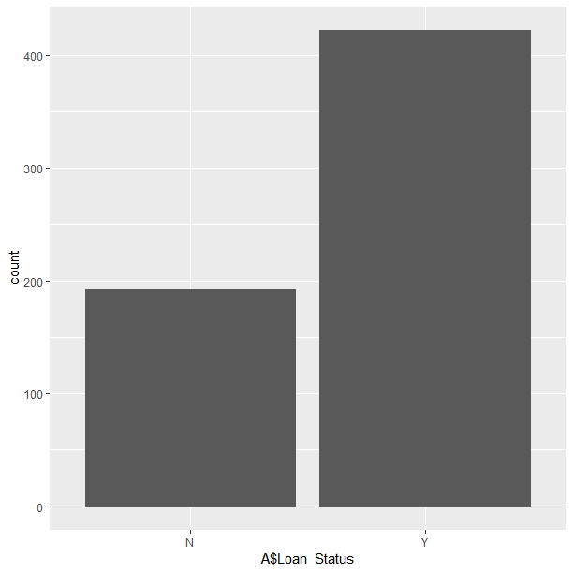

422 loans were approved and 192 were not approved.

**Credit History:**

The credit history record.

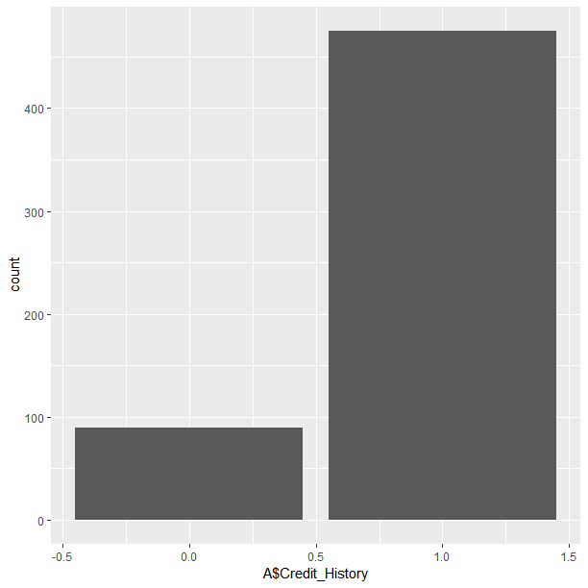

In this image ‘1’ represent the people who have credit history and ‘0’ represents people who don’t have a credit history. And apart from this there were 50 people who did not provide us with the credit history.

### Correlation and multicollinearity defined

Correlation: A mutual relationship or connection between two or more things.

Multicollinearity: **Multicollinearity** is a state of very high intercorrelations or inter-associations among the variables used for prediction. It is therefore a type of disturbance in the data, and if present in the data the statistical inferences made about the data may not be reliable.

The correlation graph of the variables.

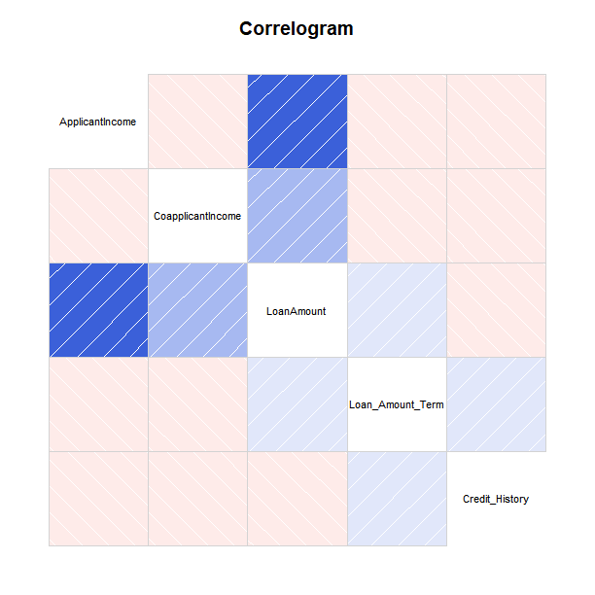

Legends:

* Darker the color more the correlation
* Blue: Positive correlation
* Red: Negative correlation

Multicollinearity reduces the precision.

So if the is the case how can the prediction be done?

By this way

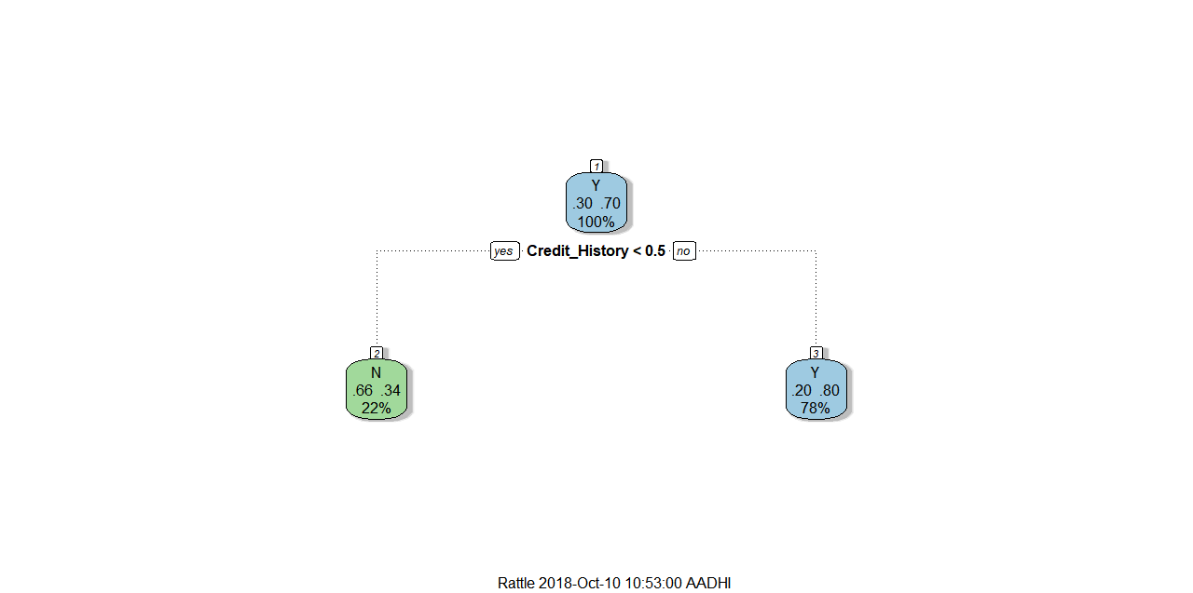

But how do we predict for those with no credit history? For that what we do is, We see if they haven’t got credit history or if they haven’t provided that information with us.

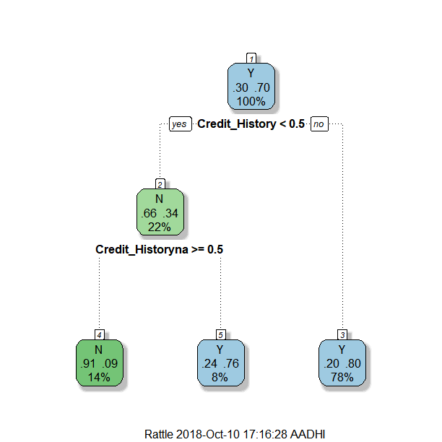

# Profiling of parameters

Let us now see to what extent does the magnitude of the variable affect the possibilities of us sanctioning the loan.

**VAR MAG**

* ApplicantIncome 0.478
* CoapplicantIncome -1.523
* LoanAmount -0.780
* Loan_Amount_Term -1.000
* Credit_History 8.989
* Credit_Historyna -6.803

The above are the results from our prediction m0odel.



* Positive sign indicates positive relationship with respect to our sanctioning of the loan
* But negative sign indicated negative relationship with respect to our sanctioning of the loan to the applicant
* **APPLICANT INCOME:**

The more the Applicant income the more the chances of approving the loan with respect to the loan amount.

* **Co – APPLICANT INCOME:**

The more the Co-Applicant income it is only one that can indicate that the applicant income is less so we need to take this into consideration more than the Applicant income and the Loan Amount. Whatsoever the Applicant Income and Loan Amount be if the Co – applicant income is high then we should consider not giving them the loan.

* **LOAN AMOUNT AND TERM:**

It is desirable to have lesser loan amount and term to increate the probability of us sanctioning the loan and the Loan amount depends on the applicant income but lesser the loan term higher the possibilities of us sanctioning the loan.

* **CREDIT HISTORY AND CREDIT HISTORY NOT PRESENT:**

These are the deciding criteria for deciding whether the loan can be given or not. Because of its very high significance.